|  |  |  |  |  |  |  |  |  |
| --- | --- | --- | --- | --- | --- | --- | --- | --- |
| Forecast Values | |  |  |  | Compiler Engine Information | | |  |
|  |  |  |  |  |  |  |  |  |
| Stand ID: | | 1124928 | | | GYPSY Model: | | 2009-May-21 | |
| Stand Type: | | Natural |  |  | Application: | | 20100713p | |
| Stand Age: | | 240 | years |  | COM DLL: | | 20100329b35 | |
| Spatial: | | NO |  |  |  |  |  |  |
| BA adjusted: | | YES |  |  |  |  |  |  |
|  |  |  |  |  |  |  |  |  |
| Input Data | |  |  |  |  |  |  |  |
|  |  |  |  |  |  |  |  |  |
| Species | | totage | topht | den | ps | ba | utilization | |
| AW |  |  |  |  |  |  | 13/7/30 | |
| SB |  |  |  |  |  |  | 15/10/30 | |
| SW |  | 124.0 | 25.26 | 212 |  | 15.37 | 13/7/30 | |
| PL |  | 250.0 | 25.26 | 346 |  | 25.09 | 13/7/30 | |
|  |  |  |  |  |  |  |  |  |
| Calculated Attributes | | |  |  |  |  |  |  |
|  |  |  |  |  |  |  |  |  |
| Species | | bhage | y2bh | si_bh | si_t | n0 | sdf | psi |
| AW |  |  |  |  |  |  |  |  |
| SB |  |  |  |  |  |  |  |  |
| SW |  | 114.9 | 9.1 | 15.1 | 12.9 | 219 | 217 |  |
| PL |  | 242.0 | 8.0 | 14.7 | 13.2 | 13,031 | 4,000 |  |

Tesera Gypsy

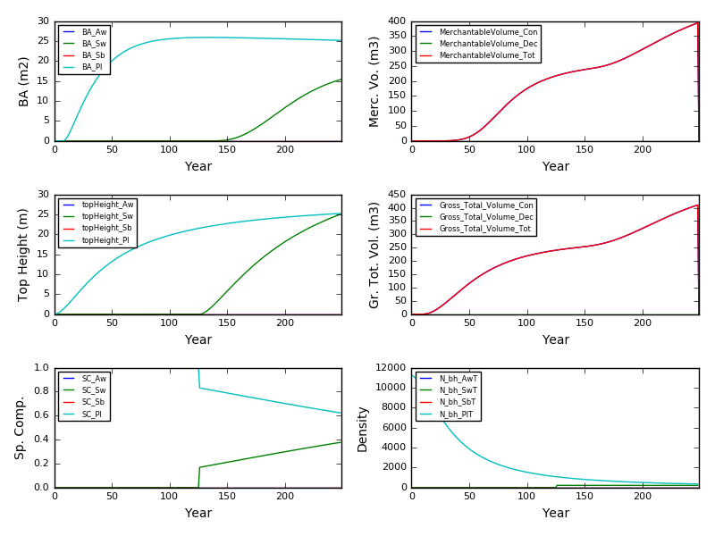

Excel Gypsy

